AUGUST 17 2019

Cardross landscape inspires watercolour painting

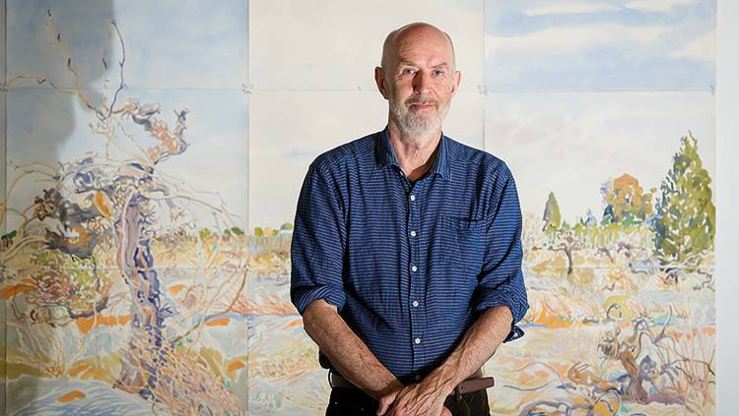

Mark Dober in front of his watercolour painting Vineyard Ruin, Cardross hanging at Mildura Arts Centre. Picture: Ben Gross

IT was pure luck that Mark Dober found himself staying opposite the only inspiration he would need to create his largest artwork to date.
The Castlemaine artist booked an Airbnb property in Cardross in July last year in the hope of finding an inspirational landscape nearby but he never expected it would be right outside the front door.
“There was an abandoned vineyard across the road and it turned out just perfectly,” he said.
For more of this story, purchase your copy of Saturday's Sunraysia Daily 17/08/2019. To subscribe to our Digital Edition Click here

